

2015 Backbone Upgrade
Alternative solution

26/01/2015, Rio de Janeiro, Brazil

Marco Teixeira, NEG

Summary
Introduction 4
1. Panama 4
1.1. Costs 5
2. Chile 5
2.1. Costs 6
3. Brazil 7
3.1. Costs 8
4. Colombia 8
4.1. Costs 8
5. Total Costs 9

Introduction

Requested by the Technical Manager the NEG carried a new study on how to implement the 2015 backbone plan, this request was done, because RedCLARA need to maximize the available resources and avoid unnecessary expenses when possible. The main guidelines for this alternative are:

- The solution must try to use the available interfaces and resources at its maximum.
- The design must be cost effective with regard to bandwidth, and active capacity. For instance, the above means that NEG can increase half of the capacity if it fulfills current bandwidth needs (based on use) and has high savings in costs.

Panama

To fulfill what was requested the NEG evaluated all available possibilities, and most efficient option is to move all 1G optical interfaces in use on the switches to the router opening space on the 3750 stack. With this space the capacity between Router –Switch will be 20 Gbps in total, and the connected links will sum 30 Gbps. The above means that the connection to the routing layer won’t be line rated if the links are used over 70% of its capacity.
Some upgrades will happened:

- A new 10G will be implemented that can connect Redclara to Miami and Chile (Shared capacity of 10G) provided by Amlight.
- A new 1G link that will increase capacity to Venezuela

The picture below shows the actual POP layout.

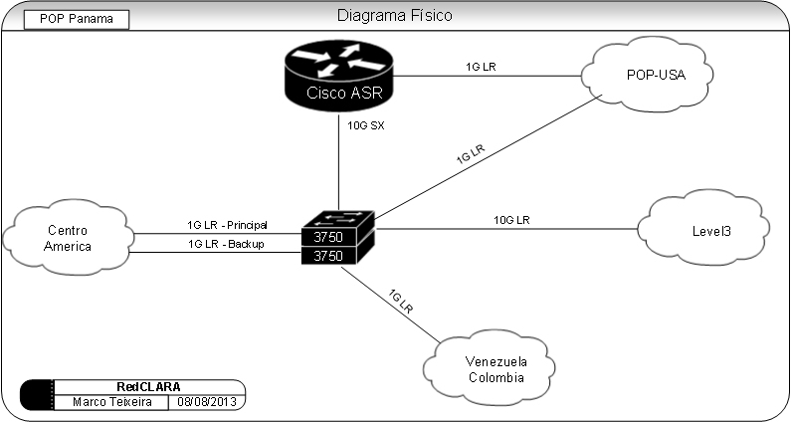
Fig 1. Actual topology

Within the changes, the layout expected should be as described below:
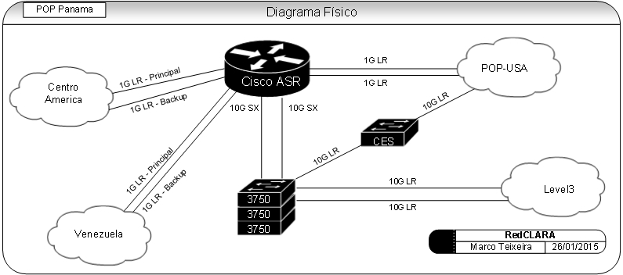
Fig 2. After upgrade topology

Costs

To be able to implement this topology the cost required will be as described below:

Qty | Part number | Unit cost | Total
5 | SFP-GE-L= | 49 | 245
1 | XFP-10G-MM-SR= | 359 | 359
1 | X2-10GB-SR | 269 | 269
1 | X2-10GB-LR | 449 | 449
 |  |  | U$ 1.322

The above costs are the equipment’s required to activate the capacity in RedCLARA’s backbone. In order to add the opening in Panama of the circuit 10G SCL-MIA, it will be necessary to add 1 Openflow capable switch and one more 3750 switch that will cost:

10G PTY-MIA Opening costs (*):

Qty | Part number | Unit cost | Total
1 | X2-10GB-LR | 449 | 449
1 | Cisco 3750 | 5.000 | 5.000
1 | CES SWITCH | 15.000 | 15.000
 |  |  | U$ 20.449

Chile

To fulfill what was requested the NEG evaluated all available possibilities, and, the same approach used in Panama will be made in Chile. The main challenge in Chile is that the links arrive at Level3 POP and the Router is collocated at Silica Datacenter; with the capacity upgrade, the NEG researched and found a way to increase the capacity between the POPs without acquiring new fibers or a DWDM system. The idea is to use one SFP capable of transmit and receive 10G using just one fiber of the pair. The technology will enable the upgrade from 10G to 10G + 10G using the same pair of dark fiber.

The picture below shows the actual POP layout.

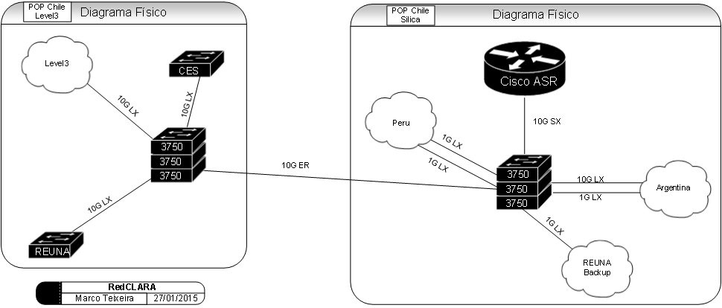
Fig 3. Actual topology

Within the changes, the layout expected should be as described below:

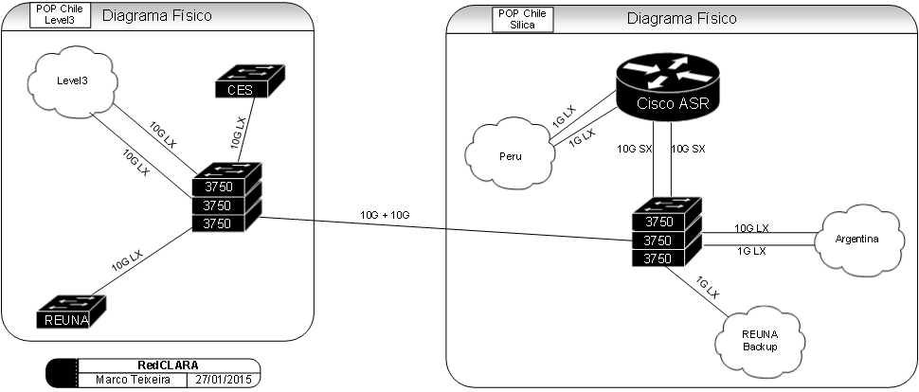
Fig 4. After upgrade topology

NOTE: Actual redundancy in Santiago is achieved with an optical ring through REUNA and ESO. This redundancy is of 1G, and it is recommended to be upgraded, to at least to 10G.

Costs

To be able to implement this topology the cost required will be as described below:

POP Level3

Qty | Type | Price | Total
1 | X2-10GB-LR | 449 | 449
2 | X2-10GBX-D-1330-40 | 1349 | 2698
 |  |  | U$ 3.147

POP Silica

Qty | Type | Price | Total
2 | X2-10GBX-U-1270-40 | 1349 | 2698
2 | SFP-GE-L= | 49 | 98
1 | X2-10GB-SR | 269 | 269
1 | XFP-10G-MM-SR= | 359 | 359
 |  |  | U$ 3.424

Brazil

To fulfill what was requested the NEG evaluated some possibilities but in Brazil the scenario was a little bit tied as almost all interfaces are already at 10G and the system Cotia-Barueri is already implemented and no room is available in Cotia to use Switches. With that in mind, just a second 10G was allocated from the Stack-Router and a second DWDM channel provisioned.

The picture below shows the actual POP layout.
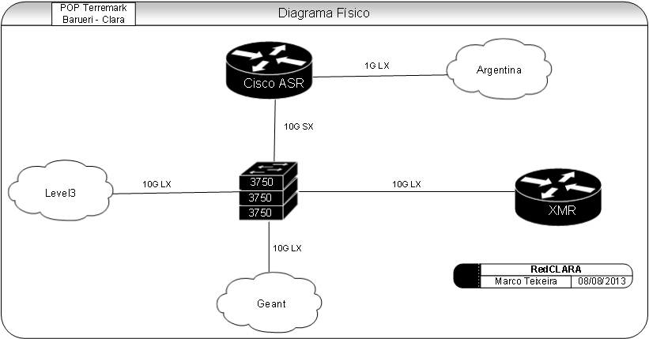
Fig 5. Actual topology

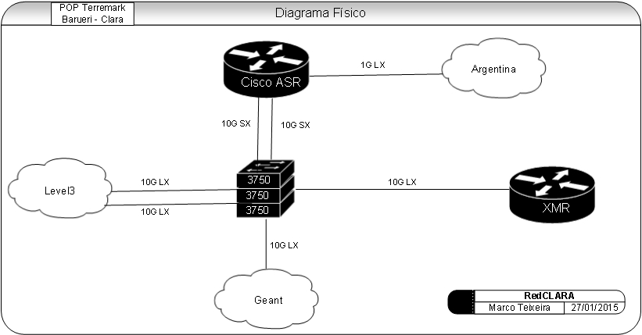
Fig 6. After upgrade topology

Costs

To be able to implement this topology the cost required will be as described below:

Quantity | Type | Price | Total
1 | X2-10GB-SR | 269 | 269
1 | XFP-10G-MM-SR= | 359 | 359
1 | X2-10GB-LR | 449 | 449
2 | 10G transponder Padtec | 8200 | 16.400
 |  |  | U$ 17.477

Colombia

The NEG evaluated the possibility to use the pair of switches that are already available in Bogota to receive the 10G ring that will be opened in Colombia. With this configuration, Renata will have to choose one main link (north to Panama or south to Chile) and one backup link. With this in mind all routing will flow through this main node and redundancy can be achieved through two peering’s with Panama and Santiago PoPs, this option adds complexity, nevertheless is functional.

As Bogota does not possess an active POP today there will be only one layout.

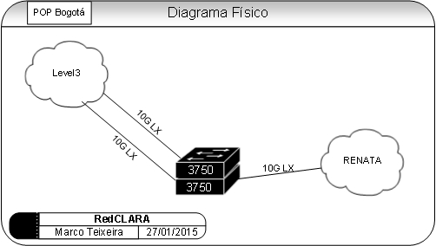
Fig 7. After upgrade topology

Costs

To be able to implement this topology the cost required will be as described below:

Quantity | Type | Price | Total
3 | X2-10GB-LR | 449 | 1347
 |  |  | U$ 1.347

Total Costs

To implement the solution the investment required will be of:

Solution | PoP | Cost
SCL-SAO-PTY 10 Gbps ring upgrade | Panama | U$ 1.322
SCL-MIA 10 Gbps opening in Panama | Panama | U$ 20.449
SCL-SAO-PTY 10 Gbps ring upgrade | Santiago | U$ 6.571
SCL-SAO-PTY 10 Gbps ring upgrade | Sao Paulo | U$ 17.477
SCL-SAO-PTY 10 Gbps ring upgrade | Bogotá | U$ 1.347
Total RedCLARA upgrade |  | U$ 10.371
Total Panama Opening  (Openflow switches y 3750) |  | U$ 26.717
Padtec transponders (Cotia-Barueri) |  | U$ 16.400
Total |  | U$ 47.166

The NEG estimated this value with no taxes.

